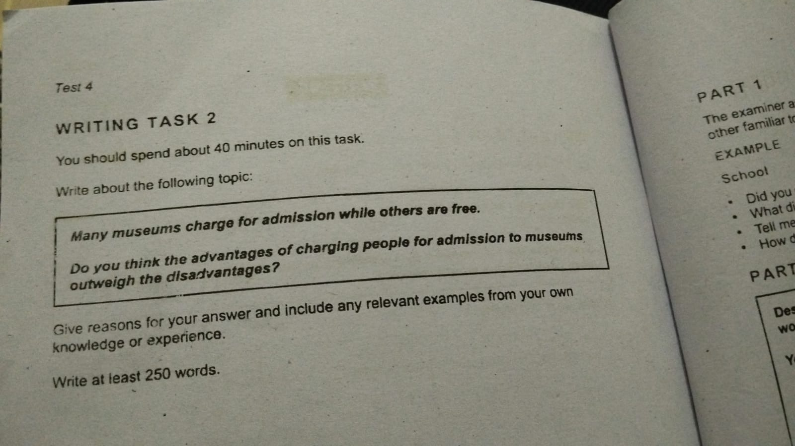
Writing Task 2
Museums portray the history, Culture and development of the society. While several museums required paid tickets, many offer free admission. Well, I think that benefits surpass the disadvantage of the imposing admission fees.

The core pros of taking the fee is that it helps to maintain the finance of the museums like if any renovation is needed or upgradation is needed so it help them in it. Like if we see he example of science museums they require to updated every six month to make realevent to the market and also require bunch of team which maintain all of it

The other main benefit of charging is that it maintain the exclusivity of the museums and it also help to gain the popalurity if we see the example of the museums world wide the museums which are asceable to everyone has the least value however museums which requires fees are more exculsevity of museums
The Primary corn of taking fee is that it s no easy for the traveler to visit because they have the budget issues so there is less visitors from aboard which become reason to decline in museums and area popularity. We see that there are lots of area in the world which are not visited for anything expect visiting the museums specially like country like France,Spain.
In Conclusion I thinks that the benefits is way more higher than the disadvantage,however there are also some propotion of corns of taking fee in the museums.

